Step 1

Download your bank statement and save it as a PDF.

Step 2:

Go to [www.22seven.com](http://www.22seven.com) and click sign up

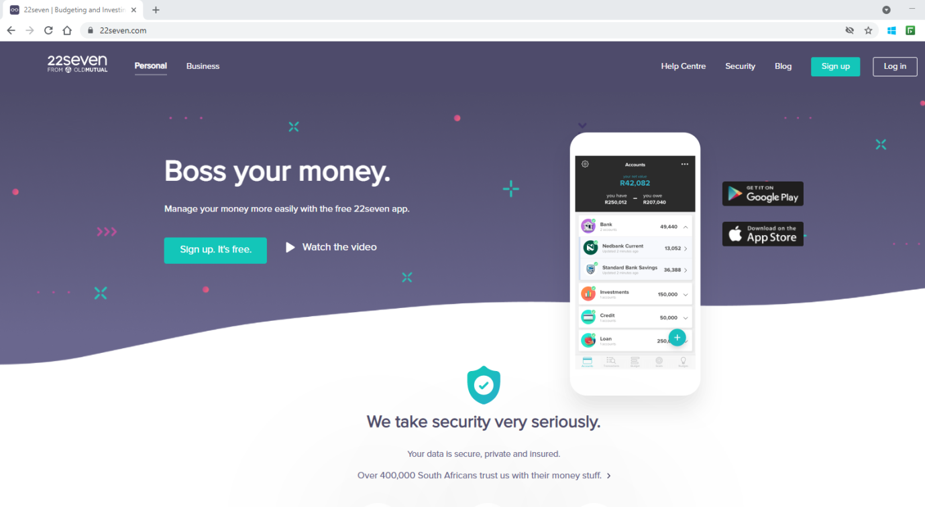

Step 2:

Enter your details and create a password, then hit Get Started

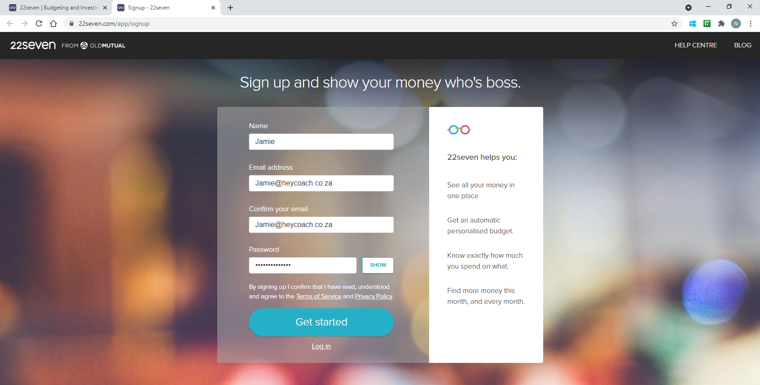

Step 3

It will ask you to link an account – you can if you would like too. We would suggest clicking on the grey area and then click on “IMPORT A BANK STATEMENT”

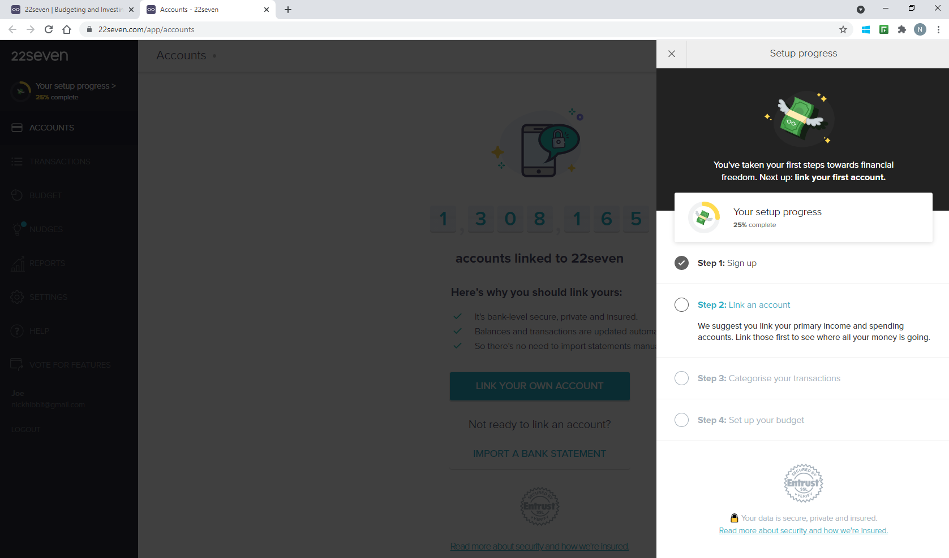

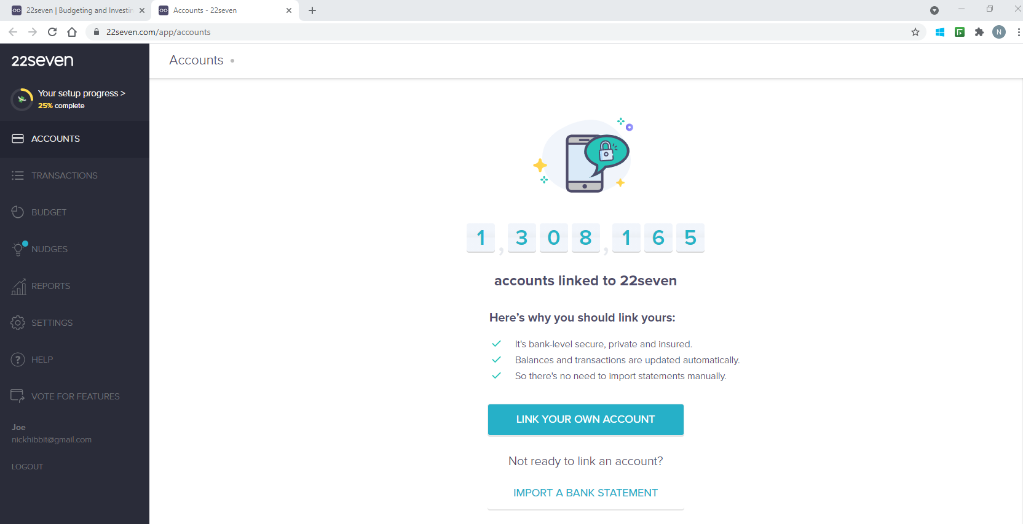

Step 4

Select the bank your bank statement comes from.

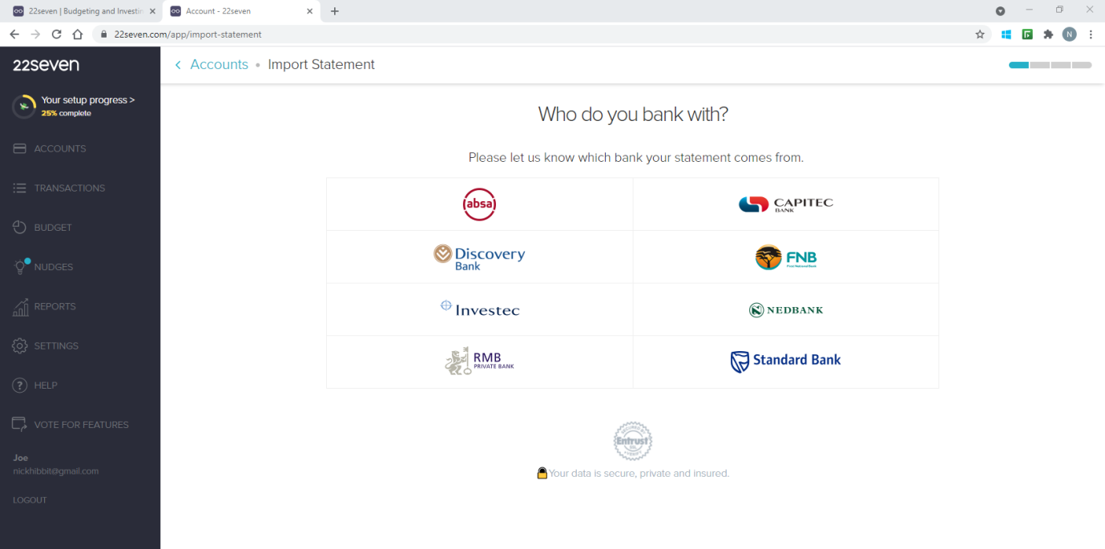

Step 5

Upload your bank Statement by dragging the file or click Browse files

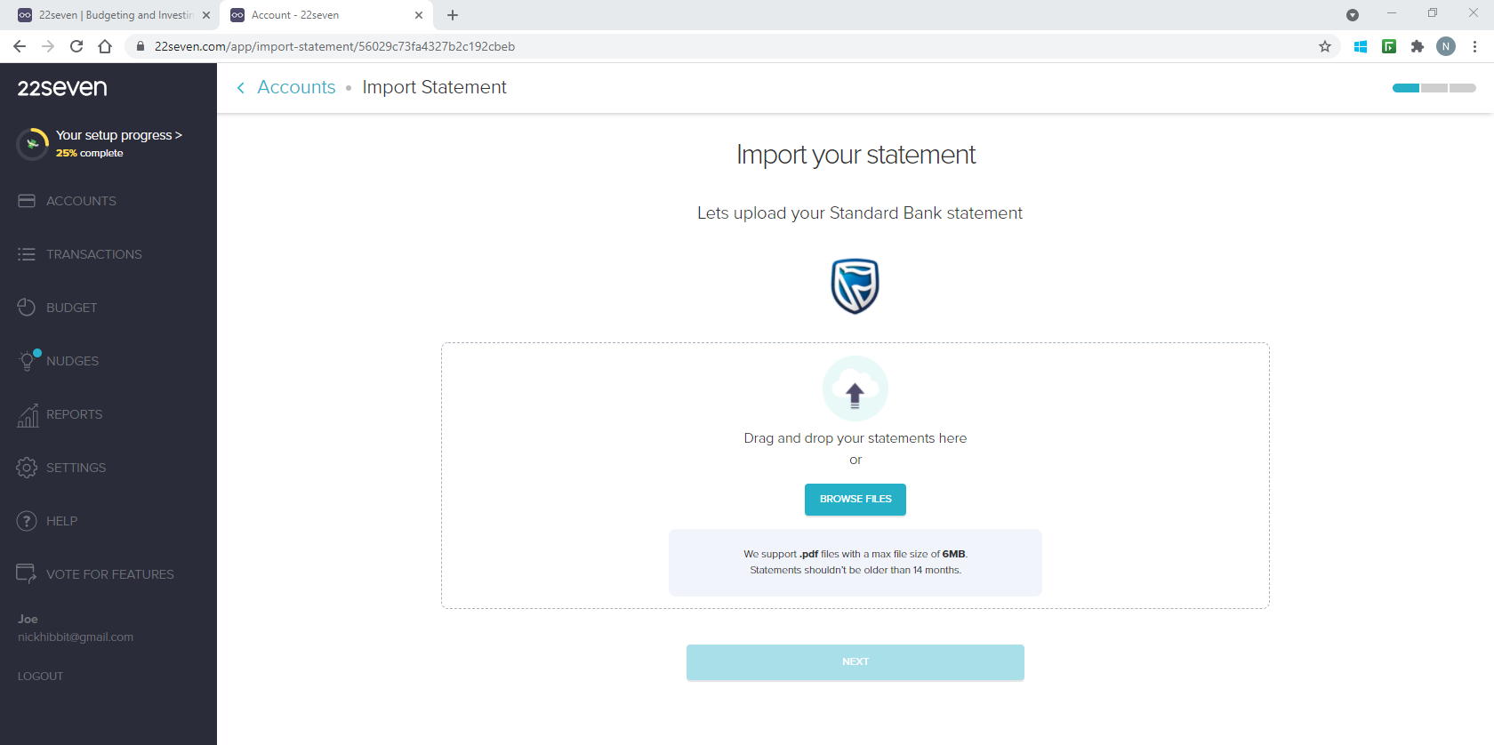

Step 6

Once you get the Upload complete verification click NEXT

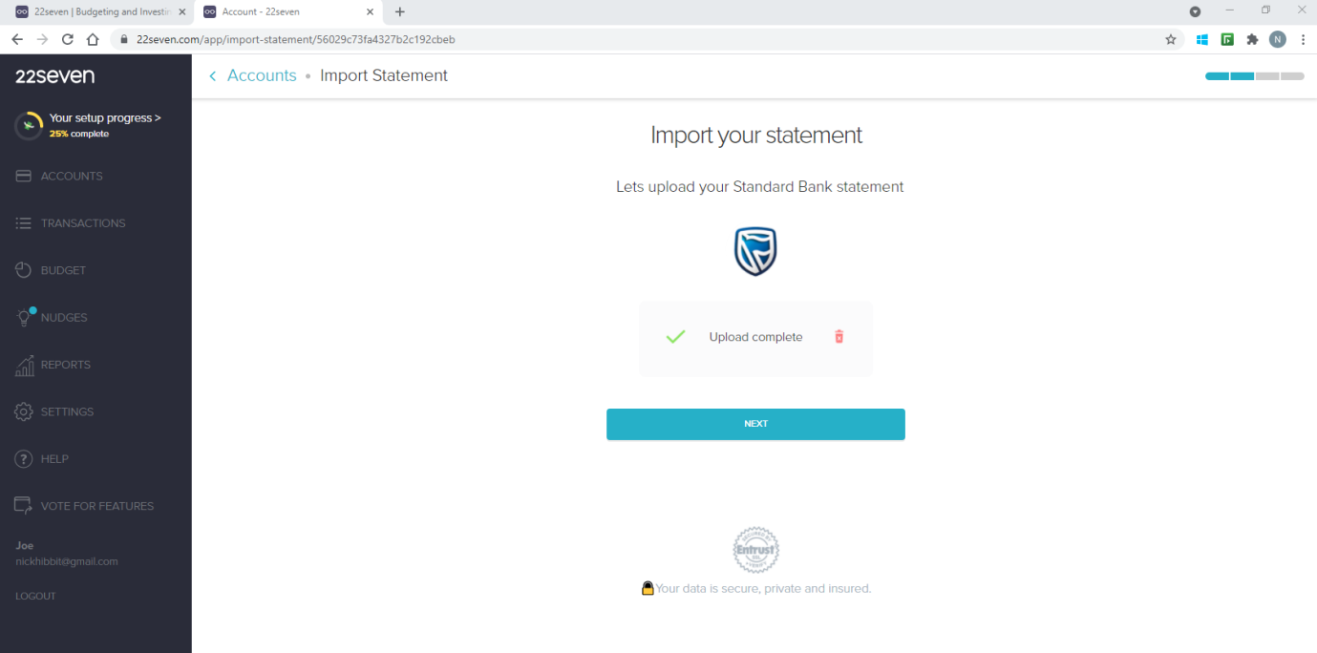

Step 7

Enter the document password if there is one, if not just hit SUBMIT

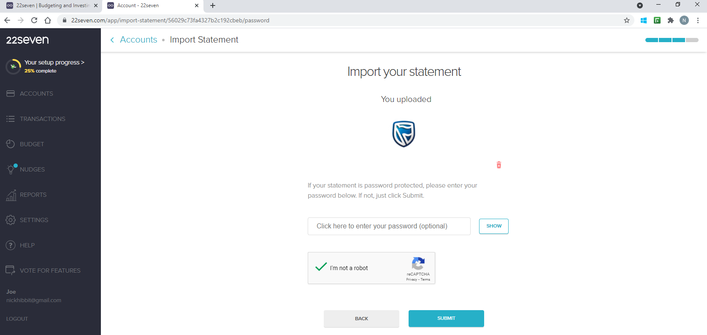

Then wait while your statement is imported, it may take a few minutes so sit back and enjoy a coffee

Step 8

Now you are ready to go, you can see all your transactionsin the transaction tab. Note that 22Seven allocates your spending into their categories, you are able to change these if you would like.

Enjoy the journey

Team HeyCoach